**DAILY ONLINE ACTIVITIES SUMMARY**

|  |  |  |  |  |  |  |  |  |
| --- | --- | --- | --- | --- | --- | --- | --- | --- |
| **Date:** | **04-06-2020** | | | | | **Name:** | **Anix Jugal D’Cunha** | |
| **Sem & Sec** | **8 sem , A sec** | | | | | **USN:** | **4al16cs013** | |
| **Online Test Summary** | | | | | | | | |
| **Subject** | | **SMS** | | | | | | |
| **Max. Marks** | | **60** | | **Score** | | | **60** | |
| **Certification Course Summary** | | | | | | | | |
| **Course** | **Python for Penetration Testers** | | | | | | | |
| **Certificate Provider** | | | **Udemy** | | **Duration** | | | **2 hours** |
| **Coding Challenges** | | | | | | | | |
| **Problem Statement:**  Program to find HCF of two numbers | | | | | | | | |
| **Status: Completed** | | | | | | | | |
| **Uploaded the report in Github** | | | | | **yes** | | | |
| **If yes Repository name** | | | | | **alvas-education-foundation/dcunhaanixjugal** | | | |
| **Uploaded the report in slack** | | | | | **yes** | | | |

Online Test Details: (Attach the snapshot and briefly write the report for the same)

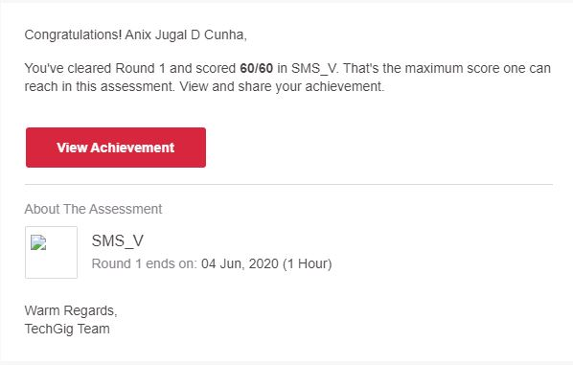

Certification Course Details: (Attach the snapshot and briefly write the report for the same)

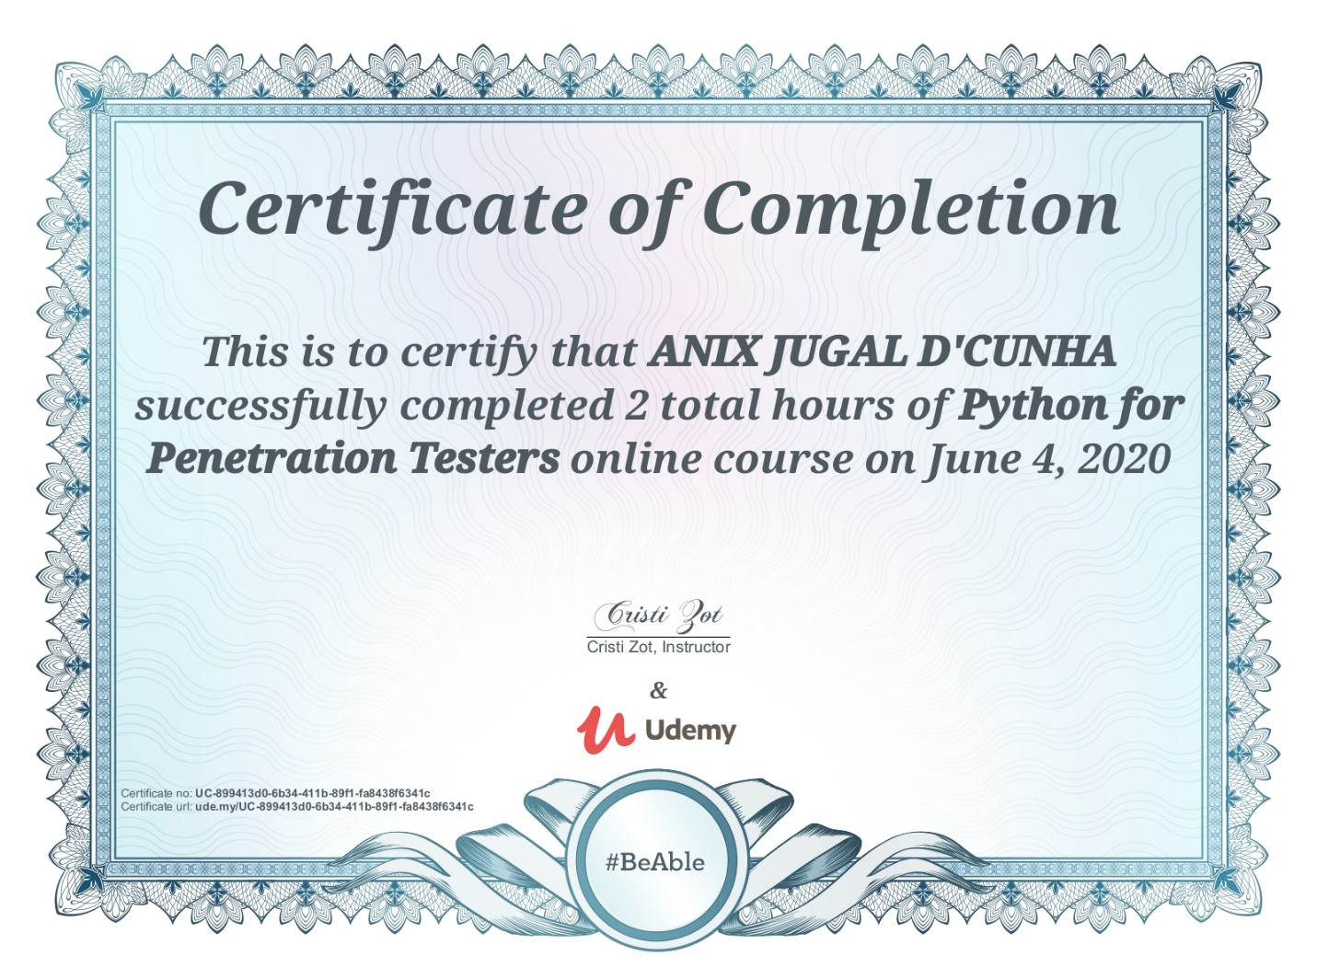

Coding Challenges Details: (Attach the snapshot and briefly write the report for the same)

Program 🡪 Program to find HCF of two numbers

Top of Form

Bottom of Form

Top of Form

Bottom of Form

|  |  |
| --- | --- |
|  |  |
|  |  |
|  | defcompute_hcf(x,y): |
|  | if x>y: |
|  | smaller=y |
|  | else: |
|  | smaller=x |
|  | for i in range(1,smaller+1): |
|  | if((x%i==0)and(y%i==0)): |
|  | hcf=i |
|  | return hcf |
|  | num1=54 |
|  | num2=24 |
|  | print("The H.C.F.is",compute_hcf(num1,num2)) |